FOR IMMEDIATE RELEASE
November 6, 2015: Rain Barrel Rebates Available for Paso Robles Residents
The rainy season is coming! Now is the time to start thinking about harvesting that rain water. The Upper Salinas-Las Tablas Resource Conservation District has a limited number of rebates still available for residents of Paso Robles who install rain barrels on their homes or businesses. Residents who submit a receipt and a photo of their installed rain barrel may be eligible for a one-time $75 rebate. Rain barrels are an excellent way to conserve water and to prevent storm water runoff from polluting our watersheds. Even a small storm can provide days of landscape irrigation with the use of a rain barrel.
The rain barrel rebates are part of the Centennial Creek Restoration Project, now in its final stages of construction. The severely degraded creek bed has been restored to prevent erosion and downstream pollution.
For more information, please call (805)434-0396 ext. 5
This project is funded by the National Fish and Wildlife Foundation, in partnership with PG&E.
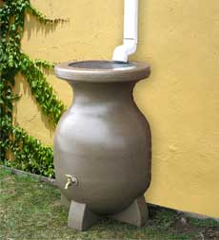
###

The Upper Salinas-Las Tablas Resource Conservation District is a special district of the State of California operation as a nonprofit. Our mission is to provide services and education to landowners supporting their management and stewardship of soil, water and natural resources.

