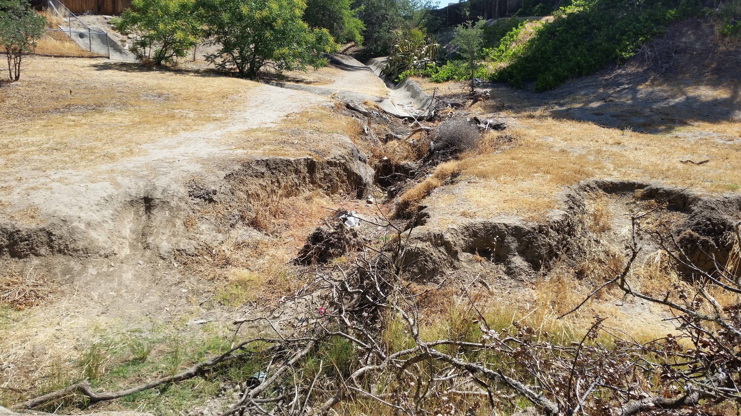
Concrete lined side-channel causing erosion and incision of the stream channel.

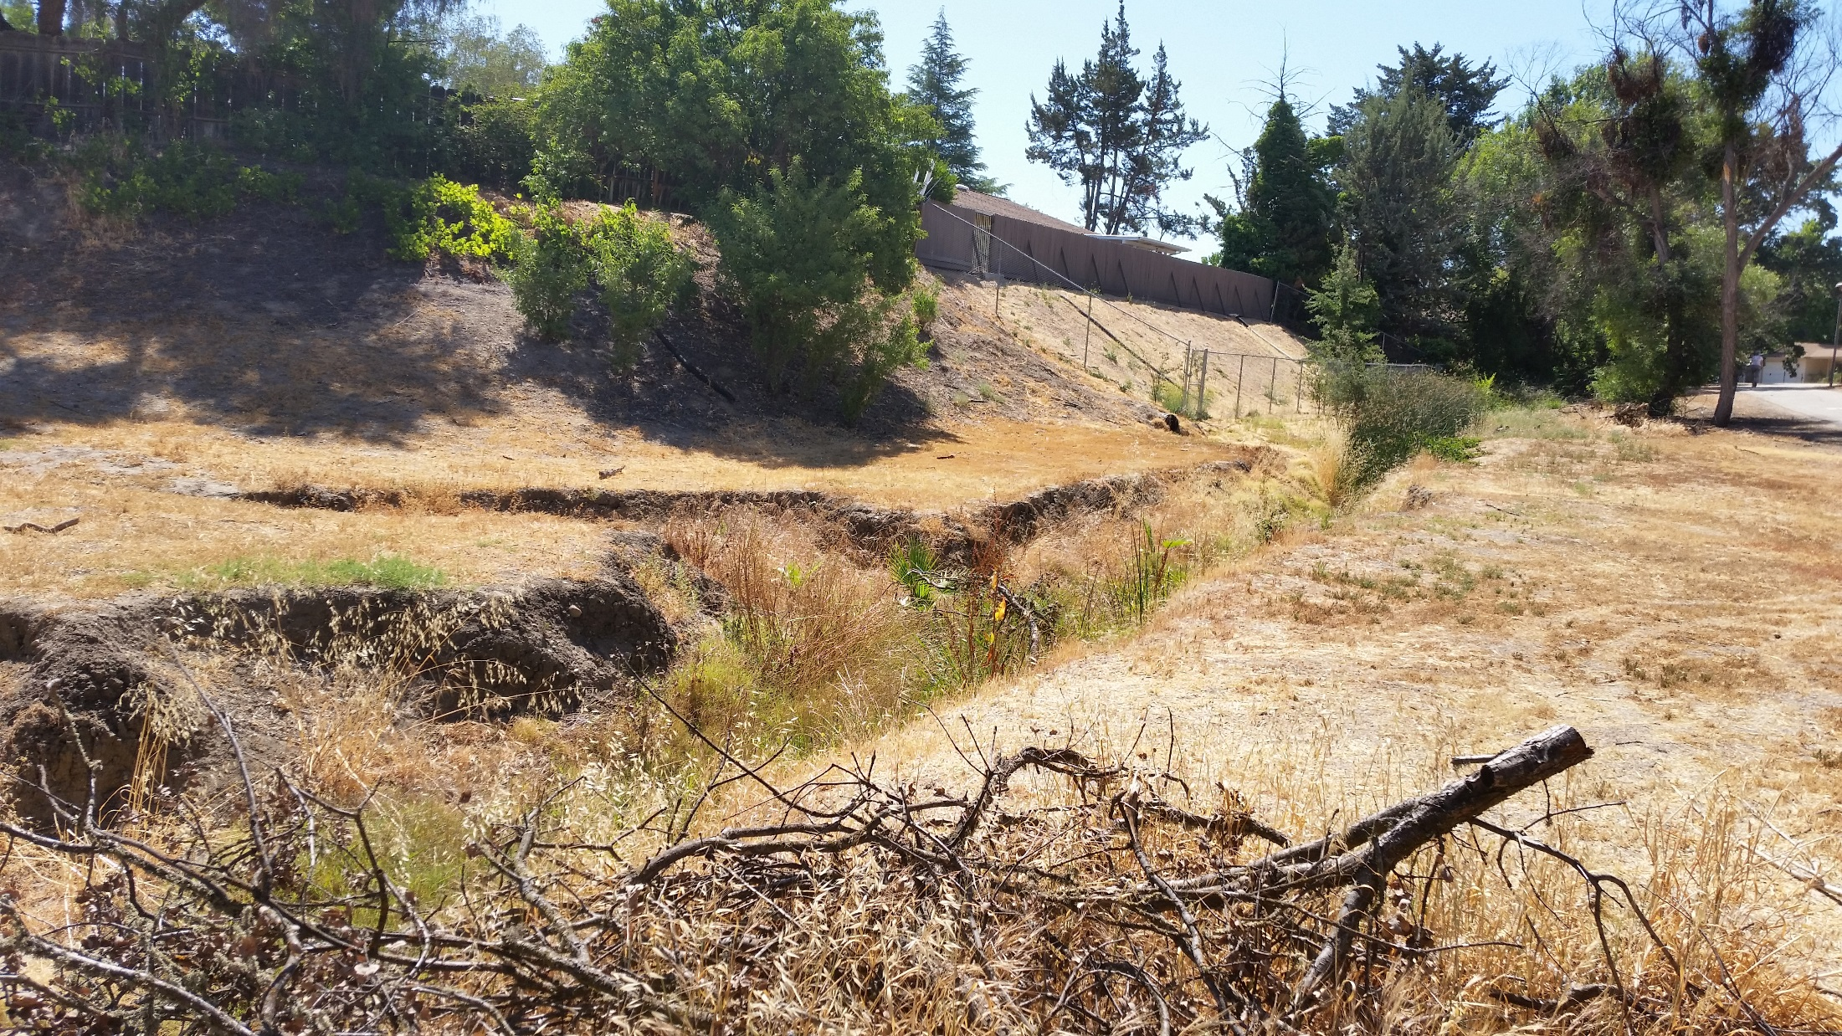
Looking upstream. Active erosion occurring along left-bank. Little to non-existent native riparian vegetation.

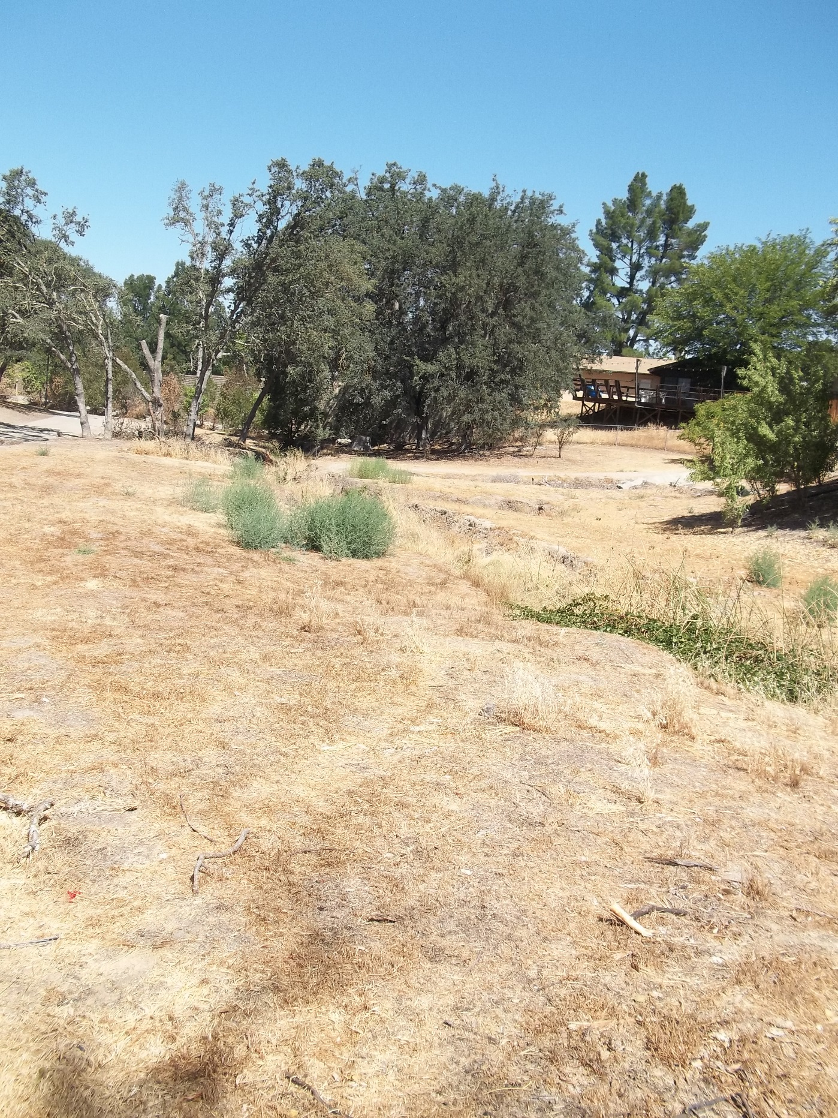
Sewer line
Looking downstream at project area. Note lack of vegetation in project area and
NRCS/USFWS engineered design plans used for implementation.
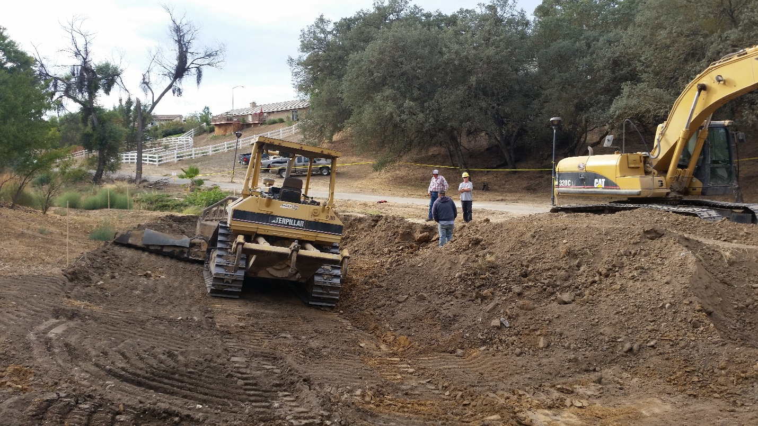
Heavy equipment doing initial grading

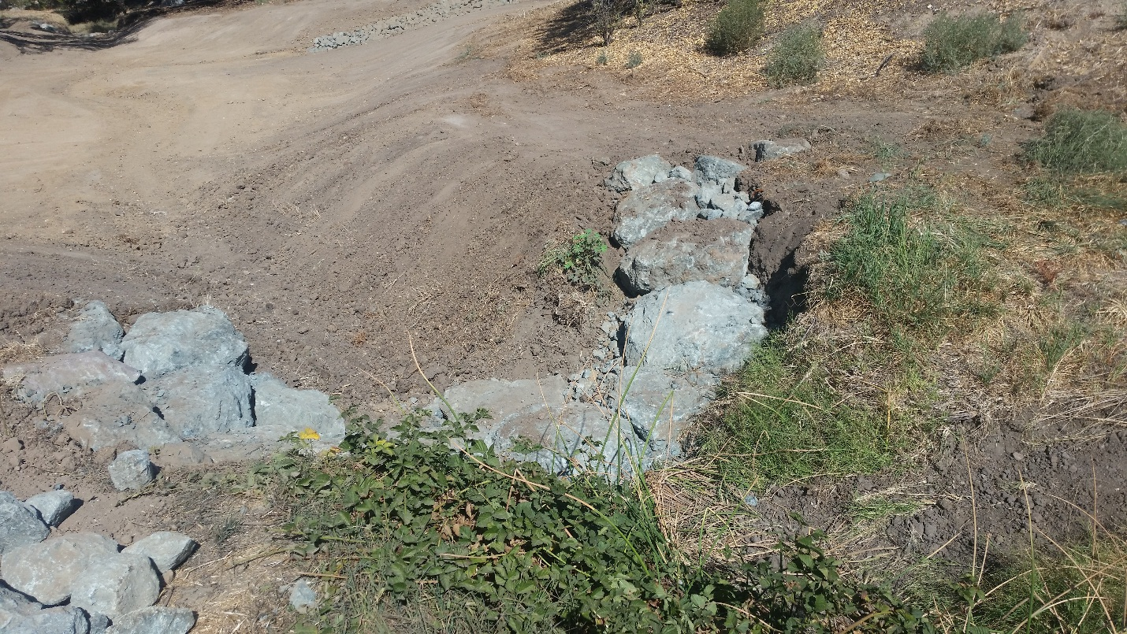
Installing rock structures to control flows

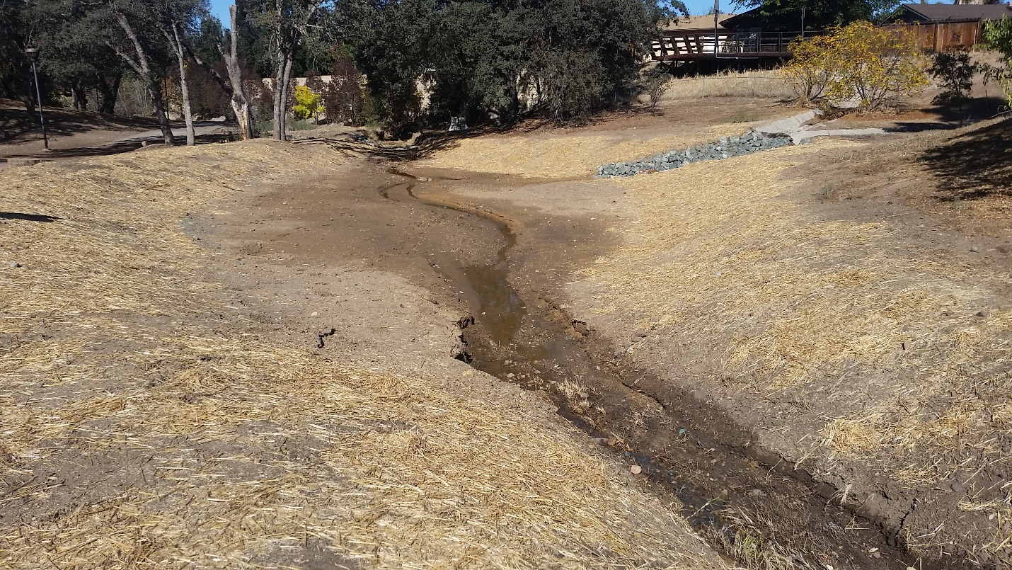
Site read for revegetation of native riparian plants
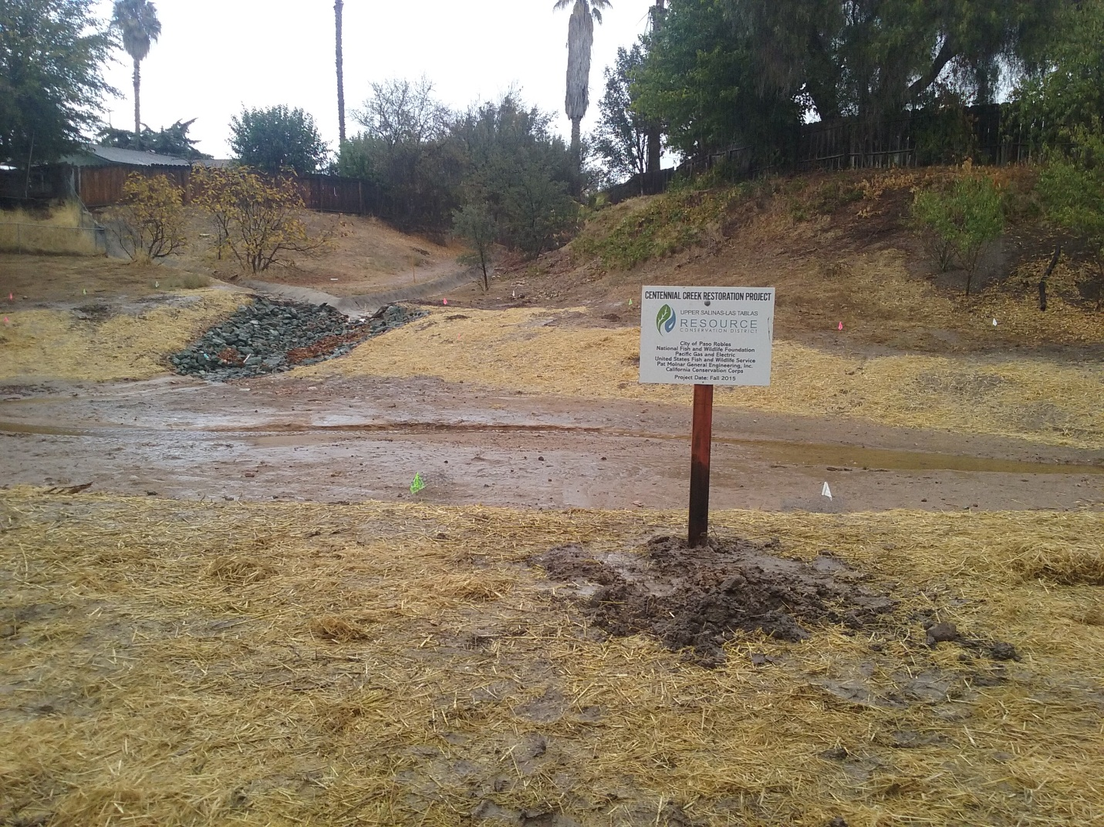
Signs illustrating the number of partners involved in the project: additional signs to be placed in spring 2016

